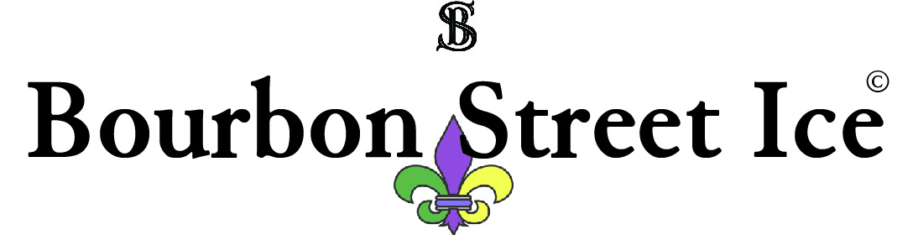
Contact Dionne C.  Telephone 770-693-5947 (store)  Cell 404-775-7340  Email bourbonstreetice@gmail.com  Website www.bourbonstreetice.com | FOR IMMEDIATE RELEASE  August 18, 2017

Bourbon Street Ice Now Open In Kennesaw

Natural and Organic Sno-Ball and Ice Pop Shop Now Open
Kennesaw, GA, August 18, 2017– Bourbon Street Ice, LLC. announces the opening of a unique spin on a delicious New Orleans-style dessert restaurant. Bourbon Street Ice, located in Kennesaw in the Publix Shopping Center at Barrett Pkwy, and Old 41 Highway is an upscale New Orleans themed all natural and organic Sno-Ball and Ice-Pop shop that’s sure to leave your sweet tooth satisfied and taste buds craving for more.
“You won’t find artificial colors or corn syrups here as our treats are made without the use of artificial sweeteners, colors, flavors, or preservatives.” D. Carter, Operations Manager.
Bourbon Street Ice has something for everyone. Our sno-balls, (ice shaved to a fluffier-than-snow consistency) are infused in syrups bursting with flavor. We’ve been open for over three weeks and are already known for our stuffed sno- balls! Our stuffing’s range from a selection of organic ice creams to our very own homemade cheesecake! The most popular combo is our New Orleans Cheesecake which is a strawberry sno-ball stuffed with cheesecake and topped with our homemade organic whipped cream & fresh strawberries! We also offer a variety of delicious hand-crafted ice pops made with organic local produce when available. With a wide variety of toppings from organic chocolate syrup and sprinkles, to gummy bears and homemade pralines, there is always a new reason to visit. We believe in the importance of sharing fresh, natural, and organic goodies while also using practices to preserve our environment such as recyclable cups & spoons. Vegan Options and varieties are also available.
Bourbon Street Ice was created with a vision of PURE, without the sacrifice of taste by a husband and wife duo. It all began one hot summer when the pair visited New Orleans, hometown of the Mrs., where she introduced him to the treat that would change their lives forever, the sno-ball. It was the most amazing thing except for artificial colors, flavors, and high fructose corn syrup to name a few. “We know firsthand what it is like having a kid with sensitivities to these chemicals and behavior issues related to dyes. It was hard watching him ask for popular treats and having to say no while other kids enjoyed them. It was even more difficult watching his behavior spiral out of control at times as a side effect of these chemicals.” Dionne C. So after quite a bit of research, and connecting with many other parents who shared this yearning, they set out to perfect this New Orleans confection.
“We’re so excited to share with you our natural and organic hand crafted Sno-Balls, Ice-Pops, and more!” When you enter, you’ll be welcomed with New Orleans’ music, Mardi Gras beads, and lagniappe- a little something extra. Just ask for a taste!! It’s lagniappe! As we say in New Orleans, Laissez le bon temp rouler! Let the good times roll

“Beads! Organic! Pretty much two of my favorite things.
The praline is to die for! Cheesecake taste like your grandma just whipped it up in the kitchen.” Tasha Tipton reviewed Bourbon Street Ice — 5 st ar
July 29 at 1:58pm ·

Bourbon Street Ice: Come taste the NATURAL difference.
# # #
If you would like more information about this topic, please contact Dionne C. or Bernard N. at 404-775-7340 (cell) or 770-693-5947 (store) or email at bourbonstreetice@gmail.com.
Location: 1635 Old 41 Highway, Kennesaw, GA 30152

